Honey Hollow Watershed: Riparian Buffer Restoration Project
Mini-Grant Final Report

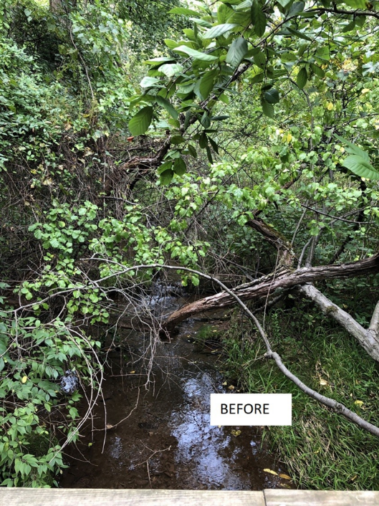
Bucks County Audubon Society at Honey Hollow is the steward of the historic Honey Hollow Watershed, which celebrated its 50th Anniversary as a National Historic Landmark in 2019. The farmers of the watershed banded together to develop soil, water and wildlife conservation measures that protected the watershed. In our commitment to be a steward of the Honey Hollow Creek, we were excited to be able to continue the restoration of the east branch of the creek.
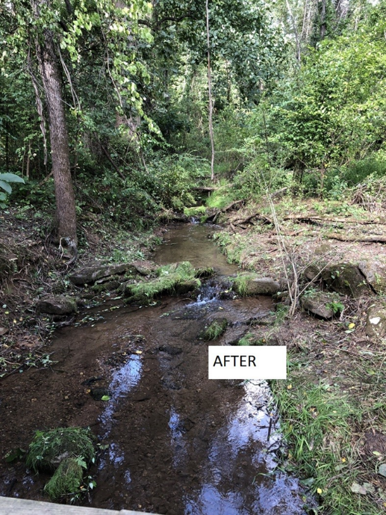
The section of the creek that we selected for this year is upstream of the 2019 project. The site faces many issues, including stream bank erosion, sediment from erosion upstream, invasive plants, the increased stress of more severe storms, and a large loss of tree canopy due to dead Ash trees.
The project was done in close partnership with the Master Watershed Stewards, and Steward Joan Stelmach was instrumental in the project planning and recruiting of volunteers. We hosted five work-days for the project in October and November. Due to COVID-19, we kept the groups small, everyone wore masks and tried to keep social distance.
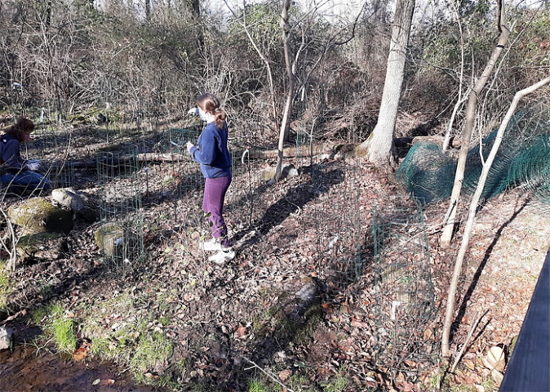
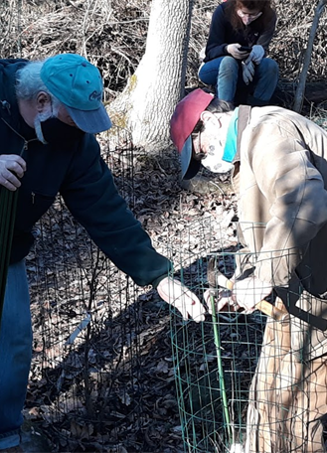
During the work-days, volunteers did significant work removing invasive plants, planting native trees that will help to stabilize the stream and provide vital habitat for birds and wildlife, and overall improving our stream ecosystem. In all 28 volunteers, most Master Watershed Stewards, but also students from New Hope Solebury National Honor Society, put in over 100 volunteer hours on this project, and planted and caged for deer protection 150 native trees and shrubs.
Joan worked closely with Nick D’Amato from Gino’s Native Plant Nursery in Wrightstown, and another Master Watershed Steward. Gino’s was able to help with plant selection, as well as providing the plants at wholesale costs, special delivery and Nick even stayed to help plant.

